
Paul Henry, MD
“Compassionate, competent Peter Daut, MD
eye care for generations” Sarah Covey, MD

741 E. Van Asche Drive, Fayetteville, Arkansas

Welcome to Henry Eye Clinic!
Thank you for choosing us for your cataract surgery consultation. For over 90 years, Henry Eye Clinic has been a trusted provider of exceptional eye care and surgical services in Northwest Arkansas. We are fortunate to practice in an era of incredible advancements in cataract surgery, and we remain dedicated to offering our patients the latest and most advanced surgical technology available.

This cataract information packet has been thoughtfully prepared to guide you in making informed decisions about your surgery options. At Henry Eye Clinic, we understand the profound importance of your vision. To provide the best possible care, we want to learn not only about your eye health but also about your overall health, daily activities, and hobbies. This personalized approach, combined with the results of your eye exam, allows us to recommend intraocular lenses that align with your lifestyle and vision needs.

Preparing for Your Preoperative Appointment
- Please carefully review the materials in this packet, complete the included questionnaires, and bring them to your preoperative appointment.
- If you wear contact lenses, discontinue use two weeks prior to your preoperative appointment and switch to glasses.
- All patients should begin using artificial tears (lubricating eye drops such as Refresh, Systane, or TheraTears) four times daily to improve the accuracy of surgical measurements.

What to Expect During Your Preoperative Visit
On the day of your appointment, we will:
- Measure your eyes to prepare for cataract surgery.
- Conduct a comprehensive eye exam with your surgeon.
- Review detailed surgical instructions.
- Help you select the most suitable intraocular lens.
- Schedule your surgeries.

Please note that this visit will take approximately 2–3 hours and will include dilation of your eyes, so plan accordingly.

Thank You for Trusting Us
We are honored to play a role in restoring your vision and are committed to providing you with compassionate, high-quality care. At Henry Eye Clinic, we are dedicated to helping you see clearly once again.

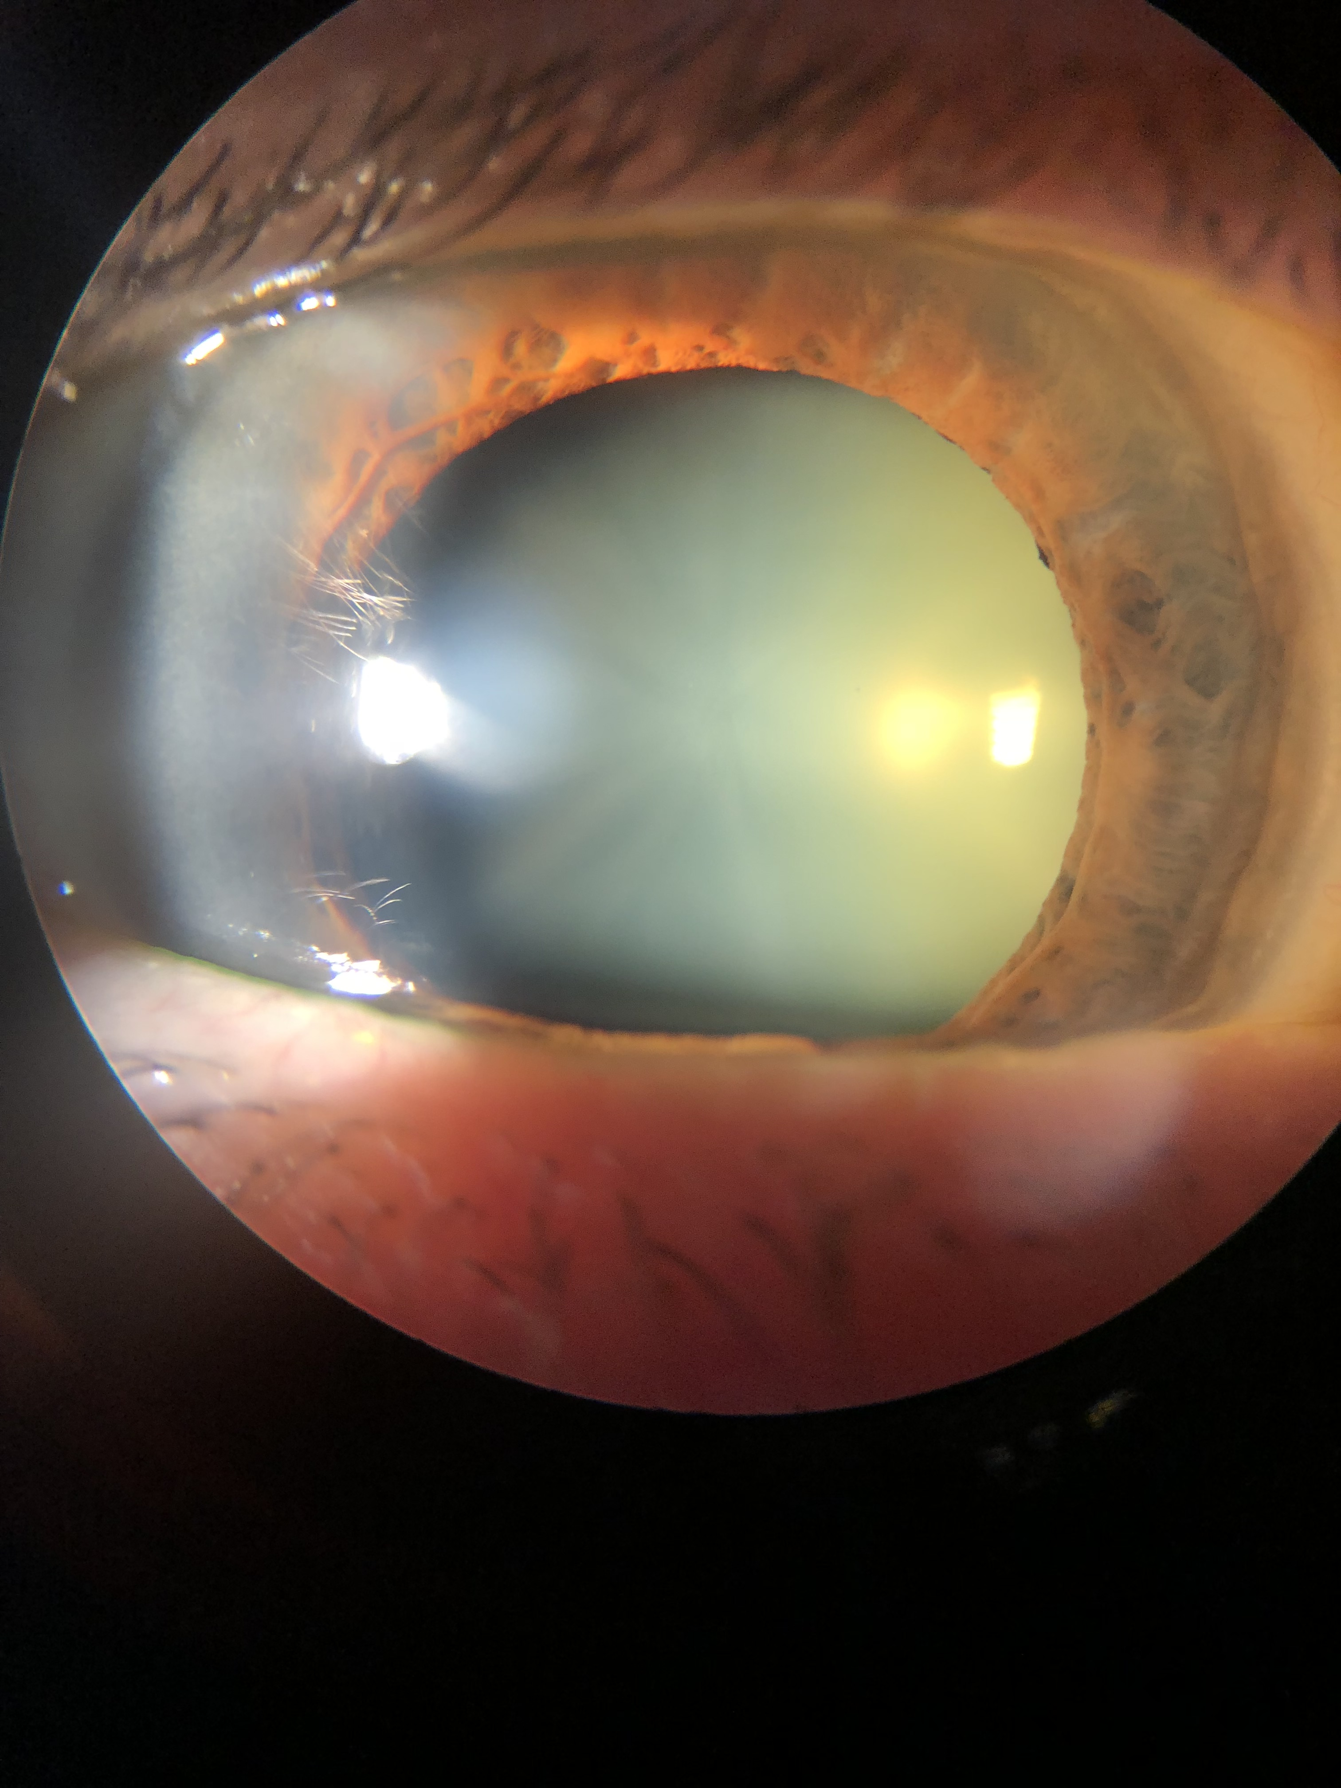
Frequently Asked Questions

What is a cataract?
The natural “lens” in the eye focuses the light on objects so that we can see clearly. Like the lens in a camera, it brings our world into focus at different distances. As we age, the natural lens becomes cloudy, discolored, and stiffer, which is then called a “cataract.” This is also part of the reason why most people need reading glasses after around forty years of age, called “presbyopia.”

What are the symptoms of a cataract?
- Cloudy, blurry, or hazy vision
Photo above shows a cataract, the yellow haze you see within the pupil
- Needing more light to see clearly
- Seeing rings or halos around lights
- Difficulty adjusting to different lighting conditions
- Poor night vision or trouble driving at night
- Sensitivity to light, glare, or headlights
- Vision that feels dim or dull, not improved by glasses or contacts
- Feeling as though glasses are dirty or the wrong prescription despite cleaning or replacing them

When do I need cataract surgery?
Cataract surgery is a personal decision. If your vision loss begins to affect your daily life and activities, it may be time to consider surgery. However, surgery is not mandatory just because you’ve been diagnosed with cataracts.
What is cataract surgery?
Cataract surgery involves making small incisions, less than 3 mm, in the clear front part of the eye called the cornea. A specialized instrument uses sound waves to break up the cataract and remove it. The cloudy lens is then replaced with a clear artificial lens, called an intraocular lens (IOL).
Simulated vision: Left: blurry without details before cataract surgery; Right: after surgery, crisp
Does cataract surgery hurt?
We use numbing drops and medication to ensure you’re comfortable and relaxed during the procedure. Most patients only notice lights changing colors. You’ll receive medication through an IV to help with relaxation and pain, but you will remain awake and breathing on your own. After surgery, mild irritation, similar to having an eyelash in your eye, is typical, but most patients don’t need more than occasional Tylenol or preservative free artificial tears to feel comfortable.

How long does surgery take?
The surgery itself takes less than 15 minutes. However, the entire process, including preparation and recovery, takes a few hours. You’ll go home the same day but will need a drive and someone to stay with you for the rest of the day.
Where is the surgery performed?
We perform surgeries at North Hills Surgical Center located at 3271 Wimberly Drive, Suite 1, in Fayetteville, Arkansas, near Washington Regional Medical Center or at the NWA Surgery Center located at 3689 N Steele Boulevard in Fayetteville.
When and where are my post op visits?
You will generally be seen the next day, within the next week, and about a month after surgery back at the Henry Eye Clinic. If you were referred by your optometrist, you will typically see them at their office a week after the second eye for co-management and to ensure continuity of care.
When can I have surgery on my second eye?
Usually, surgery on the second eye is scheduled two weeks after the first. If healing takes longer, we will adjust the timeline to ensure your first eye is functioning well before the second surgery.
When can I drive and go back to work?
Most patients see and feel well enough to return to work the next day and can drive if they feel safe and have legal driving vision in the non-operative eye.
When can I get fitted for new glasses or contacts?
You can usually be fitted for new glasses or contacts about a month after surgery on your second eye.
What are the risks?
Although cataract surgery is generally very safe and effective and the complication rate is less than one percent. Risk include infection, retinal swelling, loss of vision, and potential need for further surgery.
What are my restrictions after surgery?
For the first week after surgery, you will sleep with an eye shield at night, do no lifting over ten pounds, wear no eye makeup, and do no vigorous exercise. For two weeks, avoid dunking your head underwater in pools or hot tubs. You can read, watch TV, and engage in most normal activities immediately but avoid rubbing your eye.
When do I need to stop wearing my contact lenses?
Stop wearing contacts two weeks before your preoperative appointment. Contact lenses can temporarily change the shape of your cornea, which can affect the accuracy of measurements used to determine your new intraocular lens power.
What about my dry eyes?
Dry eyes can impact measurements for cataract surgery. Use artificial tear drops like Systane, Refresh, or TheraTears four times daily for at a week or two prior to your preoperative appointment to improve accuracy and post-surgery comfort.
Can my cataract come back?
Once removed, a cataract cannot return. However, over time, the capsular bag holding your artificial lens may become cloudy, a condition called posterior capsular opacification or “secondary cataract.” This can be treated with a quick, painless outpatient laser procedure.
Will I need to wear glasses after cataract surgery?
The need for glasses depends on your eye health and the type of lens you choose:
- Monofocal Lens: Full time glasses are needed after surgery to see clearly at all distances.
- Monovision: One eye is set for near vision; one eye set for distance vision. You must have tried this before in contacts for this to be an option because some patients to not adapt well to this change, feel off balance, or lose their depth perception.
- Toric Lens: Corrects corneal astigmatism (where the clear covering of the eye is shaped more like a football than a basketball) to allow clearer distance vision. Post operatively, most patients can drive without glasses, and only need over the counter “cheaters” to read.
- Multifocal/Trifocal/EDOF Lens: These advanced technology lenses correct corneal astigmatism AND presbyopia at the same time as your cataract surgery, giving you the best opportunity to have freedom from glasses at distance, intermediate, and near. Not an option if you have diabetic retinopathy, macular degeneration, or other retinal issues.
- Light Adjustable Lens: These advanced technology lenses also correct corneal astigmatism and presbyopia at the same time as your cataract surgery AND are able to be adjusted with a light after surgery without the need to have further surgeries. This lens is able to give freedom for glasses at most distances and is a great option for patients who have high demands for clear vision and have other ocular conditions like previous RK, LASIK/PRK, macular degeneration or corneal issues. It does require more dilated visits and more “chair time” but is customizable to your vision preferences. It offers slightly less near vision than the multifocal lenses but does not have the risk of glare or halos or rings around lights like multifocal lenses.
Is cataract surgery covered by my insurance?
Medicare and other insurances will only pay for the Monofocal lens option, but will allow you to pay the additional “out of pocket” charge for the other options to give you the once in a lifetime opportunity to have the best chance at freedom from glasses at the same time as your cataract surgery. You will discuss your options and preferences with your surgeon at your preoperative visit.

Vision Preferences

Your name ________________________________________ Date ___________________

Do you wear glasses or contacts now?
⬜ Yes: If yes: Do you wear them for: ⬜Distance ⬜ To read ⬜All the time
⬜ No

Have you ever had “monovision?” (one eye sees well at distance and the other eye sees well for near vision in contact lenses)
⬜ Yes: If yes, did you like it? ⬜ Yes ⬜ No
⬜ No

Are you interested in freedom from glasses or contacts after cataract surgery?
⬜ Yes, I would prefer to be free from glasses and contacts
⬜ No, I do not mind wearing glasses or contacts

After cataract surgery, which would you prefer?
⬜ Full time glasses
⬜ Part time glasses: ⬜ For reading ⬜ For computer ⬜ For distance
⬜ As little time as possible in glasses or contacts

What is/was your job ? ____________________
What are some of your hobbies? ____________________
When on vacation or out of your element, do you tend to tense up? ⬜ Yes ⬜ No
Do you tend to get stressed by change? ⬜ Yes ⬜ No
Would friends/family describe you as a picky, meticulous, or a “worrier?” ⬜ Yes ⬜ No

Which words describe you? (check all that apply)
⬜ Patient ⬜ Easy-going ⬜ Middle of the Road ⬜ Impatient ⬜ Stressed Out
⬜ Calm ⬜ Laid-back ⬜ Meticulous ⬜ Picky ⬜ Detail Oriented ⬜ Perfectionist
⬜ Flexible ⬜ Low Stress ⬜ Adaptable to change ⬜ Fast-Paced ⬜ High-Achieving

If you could be out of your glasses or contacts almost all of the time, would you be willing to compromise and see glare and halos around lights or occasional “rings” in your vision?
⬜ Yes (multifocal/trifocal/EDOF lenses may be an option for you)
⬜ No (light adjustable lens may be a better option for you)

Are you willing to pay an additional “out of pocket cost” for your intraocular lens to have a greater chance of freedom from glasses and contacts after surgery?
⬜ Yes
⬜ No
⬜ Maybe, I would like to discuss further
Cataract Symptoms Checklist

Your name ________________________________________ Date ___________________

Does your vision make it difficult for you to: (check all that apply)
⬜ Read a newspaper
⬜ Read a menu
⬜ Read traffic signs
⬜ Drive in bright sunlight
⬜ Drive at night due to glare from headlights
⬜ Walk downstairs
⬜ See objects in the shade when in the sunshine
⬜ Sewing or doing needle work
⬜ Recognize faces from across the room
⬜ Other: ______________________

Which cataract symptoms do you have? (check all that apply)
⬜ I feel my vision is not as clear as it used to be
⬜ I avoid driving in certain situations because I can’t see well
⬜ I need brighter lights to see than I used to need
⬜ I feel my glasses are not “good enough” anymore
⬜ Colors aren’t as bright as they were in the past
⬜ I have poor night vision
⬜ Other: ______________________

How much are cataracts affecting your daily life? (circle one)
None Mildly Moderately Severely
0 ----------------- 1 ------------------- 2 ------------------- 3 ------------------- 4 ------------------- 5

Have you ever had surgery on your eyes?
⬜ Yes: Circle all that apply: LASIK PRK LASEK RK Retinal Strabismus
⬜ No

Are you ready to have surgery to remove your cataracts?
⬜ Yes
⬜ No, I would prefer to wait

Dry Eyes Screening: Do you experience (check all that apply):
⬜ Watery Eyes ⬜ Blurry Vision ⬜ Burning ⬜ Dryness ⬜ Redness
⬜ Stinging ⬜ Irritation ⬜ Grittiness ⬜ Feel like something in eye
⬜ Need to blink to clear vision ⬜ Other: ___________

Do you use tear drops (artificial tears) currently? ⬜ No ⬜ Yes: how often? _______
Have you ever used the medication “Flomax?” ⬜ No ⬜ Yes
Name:____________________________________________ Date of Birth:_____________ Today’s Date: ______________
Referred by: _________________________________________ Name of optometrist: _______________________________

Past Medical History: PCP: ____________________________ Preferred Pharmacy: ______________________________
Last Eye Exam Date: ____________________ Do you wear: ⬜ Glasses ⬜Contacts ⬜Both ⬜ None

Please mark any condition you have now or in the past: ⬜ NONE
⬜ Dry Eyes
⬜ Cataracts
⬜ Macular Degeneration
⬜ Retinal Detachment
⬜ Glaucoma
⬜ Keratoconus
⬜ Lazy Eye/Amblyopia/Patched eye as child
⬜ High Blood pressure
⬜ Arrhythmia
⬜ Heart Attack/Stents Date: ___________________
⬜ Arthritis: ⬜ Rheumatoid ⬜ Osteoarthritis
⬜ Asthma
⬜ COPD
⬜ Stroke
⬜ Thyroid Problems
⬜ Diabetes: Type: ___________
Most Recent Blood Sugar: ________ Date: _________ HbA1c: ____________
⬜ LDL (High Cholesterol)
⬜ Cancer
⬜ Other: ___________________________
⬜ Other: __________________________

Family History: ⬜ NONE ⬜ Adopted
Please mark any conditions your family members or blood relatives have now or in the past:

⬜ Macular Degeneration
⬜ Glaucoma
⬜ Keratoconus
⬜ Retinal Detachment
⬜ Blindness
⬜ High Blood pressure
⬜ Heart Problems
⬜ Arthritis: ⬜ Rheumatoid ⬜ Osteoarthritis
⬜ Lung Problems
⬜ Stroke
⬜ Thyroid Problems
⬜ Diabetes: ⬜Type I ⬜ Type II
⬜ High Cholesterol (LDL)
⬜ Cancer
⬜ Other: ____________________________

Have you had your: ⬜Flu vaccine: Date: ___________ ⬜ Pneumococcal Vaccine: Date: ______________
Height: _______________ Weight: ______________

Review of Systems: ⬜ NONE Circle all that apply Other:
Allergy/Immunologic: | Seasonal Allergies / Immunodeficiencies
Cardiovascular: | Chest pain / Heart Failure / High blood pressure / Arrhythmia
Constitutional: | Fatigue / Fever / Weight loss
Ear/Nose/Mouth/Throat: | Deafness / Dry Mouth / Runny Nose / Sinus infection
Endocrine: | Excessive thirst / Mood swings / High blood sugar
Eyes: | Double vision/ Eye Pain / Vision loss / Glare / Flashing Lights Floaters / Dry Eyes / Watery Eyes / Light Sensitivity / Red Eye Itchy Eyes/ Trouble reading / Trouble Driving / Loss of Vision
Gastrointestinal: | Constipation / Diarrhea / Hepatitis / Ulcers / Vomiting
Genitourinary: | Blood in urine / Discharge / Genital Ulcers / Kidney stones
Hematologic/Lymphatic: | Easy bleeding / Recurrent Infections / Easy Bruising
Integumentary (Skin): | Eczema / Rashes / Itching / Poor wound healing / Jaundice
Musculoskeletal: | Joint aches / Pain / Paralysis / Stiffness/ Swelling
Neurological: | Alzheimer’s / Dementia / Fainting / Headaches / Migraines / Numbness / Parkinson’s / Seizures / Stroke
Psychiatry: | Anxiety / Depression / Memory loss / Sleeping problems
Respiratory: | Asthma / Shortness of breath / COPD / Bronchitis

Social History:
Do you smoke? ⬜ No ⬜Former Smoker ⬜ Yes: Start Date:_________ Packs per Day:_________
Do you drink alcohol? ⬜ No Yes: ⬜ Beer ⬜ Wine ⬜Spirits ⬜ Former Drinker
How Often? ⬜ Daily ⬜ Weekly ⬜ Occasionally ⬜ Socially

Allergies: (to medications or food) ⬜ NONE
_______________________(Reaction:________________) _______________________(Reaction:________________)
_______________________(Reaction:________________) _______________________(Reaction:________________)

Ocular Medications: ⬜ NONE
_____________________________________ ⬜Both eyes ⬜ Right eye ⬜ Left eye How Often_______________
_____________________________________ ⬜Both eyes ⬜ Right eye ⬜ Left eye How Often_______________

Systemic Medications (including over the counter): ⬜ NONE ⬜ See Attached list
_____________________________________Dose ___________________ Route __________________ How Often____________
_____________________________________Dose ___________________ Route __________________ How Often____________
_____________________________________Dose ___________________ Route __________________ How Often____________
_____________________________________Dose ___________________ Route __________________ How Often____________
_____________________________________Dose ___________________ Route __________________ How Often____________
_____________________________________Dose ___________________ Route __________________ How Often____________
_____________________________________Dose ___________________ Route __________________ How Often____________
_____________________________________Dose ___________________ Route __________________ How Often____________

Ocular Surgeries/Procedures: (ex: LASIK, RK, Cataract, Retina, Glaucoma, Lasers, Strabismus) ⬜ NONE
_____________________________________ ⬜Both eyes ⬜ Right eye ⬜ Left eye Approx Date: _____________
_____________________________________ ⬜Both eyes ⬜ Right eye ⬜ Left eye Approx Date: _____________
_____________________________________ ⬜Both eyes ⬜ Right eye ⬜ Left eye Approx Date: _____________

Surgeries/Procedures: (ex: gallbladder, hysterectomy, appendectomy, hip replacement, etc) ⬜ NONE
________________________________(Date:________________), ________________________________(Date:________________)
________________________________(Date:________________), ________________________________(Date:________________)
________________________________(Date:________________), ________________________________(Date:________________)

Patient Name: _________________________________________________________ Patient DOB: ___________________
Patient Information: *We are NOT providers for any Vision Plans*

Full Legal Name: ____________________________________________________________ Date of Birth: ___________________
Address: _____________________________________ City: ________________________ State: _________ Zip: ______________
Social Security: _________- _______- _________Employer: ______________________Employer Phone: ________________
Home Phone: _______________________________________________Cell Phone: _____________________________________
Email: _______________________________________________________ Preferred contact: ⬜ Home ⬜ Cell ⬜ Email
Sex: ⬜ Male ⬜Female Gender Identity: ______________________ Preferred Name: ______________________

Race: ⬜ American Indian/Alaska Native ⬜ Asian ⬜ Black/African American
⬜ Native Hawaiian/ Pacific Islander ⬜ Latin American ⬜ White
⬜ Decline to Specify ⬜ Other: _________

Ethnicity: ⬜ African American ⬜ American ⬜ American Indian ⬜ Chinese
⬜ European American ⬜ Hispanic/Latino ⬜ Jewish ⬜ Not Hispanic/Latino
⬜ Unknown ⬜ Decline to Specify

Marital Status: ⬜Single ⬜ Married ⬜ Widowed ⬜ Divorced ⬜ Minor

Language: ⬜ English ⬜ Spanish ⬜ Marshallese ⬜ Sign Language ⬜ Other: __________________

Emergency Contact: ______________________________ Relationship ______________ Phone________________________

I currently reside in: ⬜ Short Term Rehab ⬜ Nursing Home ⬜Neither

Responsible Party/Guarantor: (if patient is less than 18 years old or covered by parents’ insurance):
Name of Father ___________________________________ Date of Birth _____________ Phone ________________________
Father’s Employer ____________________________________________________ Phone_________________________
Name of Mother __________________________________ Date of Birth _____________ Phone ________________________
Mother’s Employer ___________________________________________________ Phone________________________
Medical Insurance_______________________________ Policy #_____________________ Group # _____________________
Name of Policyholder _____________________________________________________Relationship_______________________
Birthdate of Policyholder __________________Social Security # of Policyholder ________________________
Secondary Insurance Provider____________________ Policy #_____________________ Group # _____________________
Birthdate of Policyholder __________________Social Security # of Policyholder ________________________

Release of Information: I authorize Henry Eye Clinic to discuss my medical information with the following people:
Name: _________________________________________ Relationship: _______________________ Phone: _________________
Name: _________________________________________ Relationship: _______________________ Phone: _________________

I affirm the information I provided regarding my medical and patient information to be complete and accurate to the best of my knowledge. My signature below authorizes Henry Eye Clinic physicians and staff to examine me or the patient, including dilation and diagnostic testing as necessary. I have been provided access to the “Notice of Privacy Policies” and I agree to the Henry Eye Clinic Financial Agreement. I understand and agree that regardless of my insurance status, that I am responsible for the balance on this account for any professional services rendered. I understand most insurance does not cover the refraction charge (which is necessary to get a glasses or contact lens prescription today or in the future) and is $42 for regular refraction and $90 for complex refraction, and I agree to pay in full at time of service.

Signature: _________________________________________ Print Name:___________________________ Date: _____________

